**Local Control of Electricity Make Sense for the Economy and the Environment**

by Bill Powers, P.E., April 12, 2024

Rooftop solar accounts for nearly half the state’s solar capacity. Until 2024 it was being installed at the rate of over 2,000 megawatts per year. However, because of an unfavorable California Public Utilities Commission (CPUC) ruling that went into effect in mid-2023 that favors the negative position of California’s investor-owned utilities, including SDGE, rooftop solar has been hit with a severe setback.

The state, through the CPUC, is implementing rates and regulation that make it increasingly difficult to develop local clean energy.

The rooftop solar industry—which employs tens of thousands of workers in California, making rooftop solar installers the largest electric industry employer in the state—says they have lost three-quarters of their business, and expect to lay off 17,000 workers, because of the CPUC hostile rates and rules.

There are some legislative efforts to reverse the damage. These efforts currently faces opposition from the powerful private electric utilities, who have instilled widespread prejudice against rooftop solar.

Electric utilities are hostile toward rooftop solar because they fear losing sales. Rather than reducing costs as other competitive businesses would do in this circumstance, regulated utility monopolies respond by raising rates to increase revenue.

Higher electric rates would ordinarily incentivize even more customers to get rooftop solar, or find other alternatives to reduce their utility bills. But utilities are using state regulators and their monopoly power over the distribution wires to impose “exit fees” and “fixed charges” on their competitors—which act like a solar tax kickback to the utilities, making low-cost renewable energy uneconomic for most people in California—in order to maintain utility revenue and profits.

The fixed fees being pushed by the private utilities will have a destructive effect on the rooftop solar market, and will reduce the economic benefit of conserving energy. *In fact, the new rate structures are explicitly designed and intended to increase electricity consumption*.

This in turn threatens to undermine key elements of California entire clean energy and climate efforts, which increasingly *rely on electricity to decarbonize all the other sectors*, especially through electrification of transportation, buildings, and industry.

Development of *local clean energy is by far the largest driver of employment in California’s electric utility industry*. According to the solar jobs census, 78,000 Californians were working in solar energy in 2022.[1] Installation of local small scale solar is a far larger job creator than building large utility-scale projects. 80 percent of solar installation jobs are in rooftop and community solar.[2]

Solar installer pay in San Diego is good. The average solar installer pay is $75,000 per year.[3] Commercial rooftop solar installers must receive prevailing (union) wages as of January 1, 2024.[4]

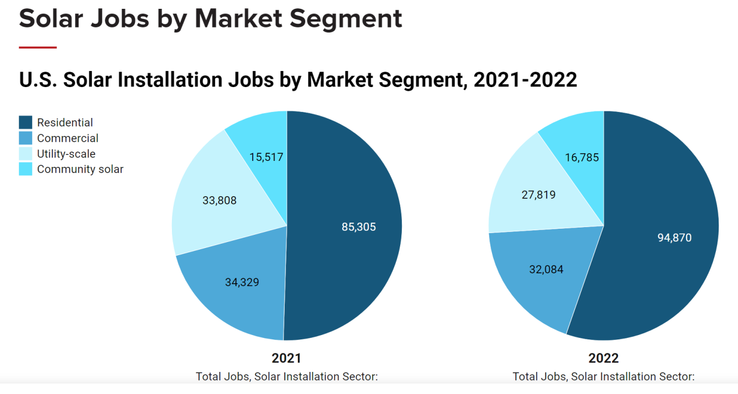

SDG&E had a total of 4,894 employees in 2023.[5] The CPUC’s *hostile rooftop solar policy eliminated 17,000 local solar jobs in 2023.* That is the equivalent employment of four utilities the size of SDG&E and—unlike this ballot initiative— the CPUC is not creating equivalent jobs for unemployed solar workers.

The state has thrown a thriving clean energy industry – the solar rooftop installer industry – under the bus in the service of the private monopoly utilities. The formation of a municipal electric distribution utility in San Diego would be a big step forward in addressing this wrongheaded political response. The municipal electric utility would not be regulated by the CPUC and would not be subject to its counterproductive actions against rooftop solar.

The municipal electric utility in San Diego would be focused on maximizing rooftop solar to reduce the overall cost of electricity delivered to residents. No transmission charges would be levied on solar generated in the City, as it would flow entirely on the low voltage local distribution grid. The transmission charges imposed by SDGE are so high – and increasing – that solar in the City becomes the cheapest supply option simply by avoiding SDGE transmission charges. Only local control and ownership of the electric distribution grid provides the framework to maximize the economic benefit of local solar power.

*Bill Powers is a professional engineer, expert witness in CPUC proceedings, and chair of the Power San Diego public power ballot initiative campaign.*

1. <https://irecusa.org/california-solar-and-clean-energy-jobs/>
2. https://irecusa.org/census-solar-job-trends/
3. Salary.com, *Solar Installer Salary in San Diego, California*, March 26, 2024: <https://www.salary.com/research/salary/posting/solar-installer-salary/san-diego-ca>.
4. AB 2143: <https://leginfo.legislature.ca.gov/faces/billNavClient.xhtml?bill_id=202120220AB2143>.
5. SDG&E SEC 2023 10K Filing, p.33., <https://investor.sempra.com/sec-filings?field_nir_sec_cik_target_id=0000086521>